// 24-25 THREAT INTELLIGENCE INTEGRATION

This report covers the integration of external threat intelligence into the Wazuh SOC lab, mapping existing detections to the MITRE ATT&CK framework, and building indicator-of-compromise (IOC) enrichment via VirusTotal and CDB threat-feed lookups. The objective was to move from raw detection ('a file changed') to enrichment ('this file is known-malicious across N vendors, tied to technique X').
$ virustotal_integration
The Wazuh Manager (192.168.56.10) was configured to submit file hashes detected by FIM/syscheck to VirusTotal automatically, using the built-in virustotal integration. Configuration was added to the manager's ossec.conf:
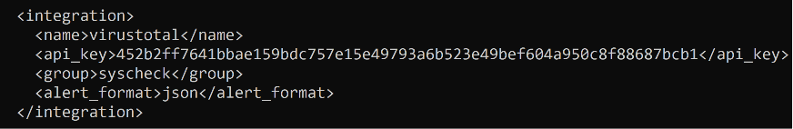
The win10-vm agent was configured with a dedicated realtime FIM watch on a test directory to trigger enrichment on demand:
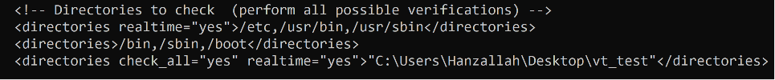

$ finding: deprecated api endpoint
Initial testing showed FIM detecting file changes correctly (confirmed via alerts.log, rule 550/554), but the VirusTotal integration failed silently on every attempt, logging repeated UnicodeDecodeError and generic Exception entries in ossec.log. A valid API key was confirmed independently via a direct curl request to the VirusTotal v3 API, which returned a full, correct scan report — ruling out a credentials problem.
Root cause: Wazuh 4.14.5 ships its virustotal integration script (/var/ossec/integrations/virustotal.py) hardcoded against the deprecated VirusTotal API v2 endpoint (vtapi/v2/file/report), authenticating via a URL query parameter. VirusTotal has phased out this method in favor of API v3, which authenticates via an x-apikey header. The mismatch caused VirusTotal to return non-JSON responses that the script's v2-style parser could not handle, producing the decode errors.
This is a genuine visibility gap worth documenting on its own: a fully valid, correctly configured integration silently fails because the vendor-shipped script targets a decommissioned API version. Without checking ossec.log directly, this would present as 'the integration doesn't work' with no clear cause.

$ remediation
- Patched query_api() in virustotal.py to call the v3 endpoint (/api/v3/files/{hash}) and authenticate via the x-apikey header instead of a URL parameter.
- Updated the response parser to read the v3 response schema (data.attributes.last_analysis_stats) instead of the v2 flat positives/total fields.
- Rebuilt the permalink field to use the current VirusTotal GUI URL format.
- Validated the patched script with Python's ast module before restarting the manager, to catch syntax errors pre-deployment.
$ validation
With the patch applied and integrator.debug temporarily raised to capture full script output, a fresh EICAR test file dropped into the monitored directory triggered a complete, successful enrichment cycle end to end:
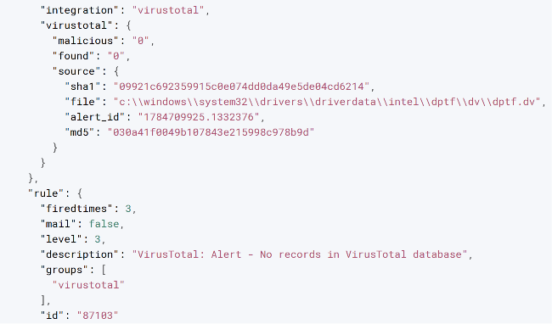
VirusTotal hit in the Wazuh dashboard — file hash, VT score, and alert detail
$ mitre_att&ck_technique_mapping
The MITRE ATT&CK module was enabled in the Wazuh dashboard (Threat Intelligence → MITRE ATT&CK) to review how existing detections from Weeks 1–3 map to the ATT&CK taxonomy. This section documents the techniques identified in the alert history and what each represents.
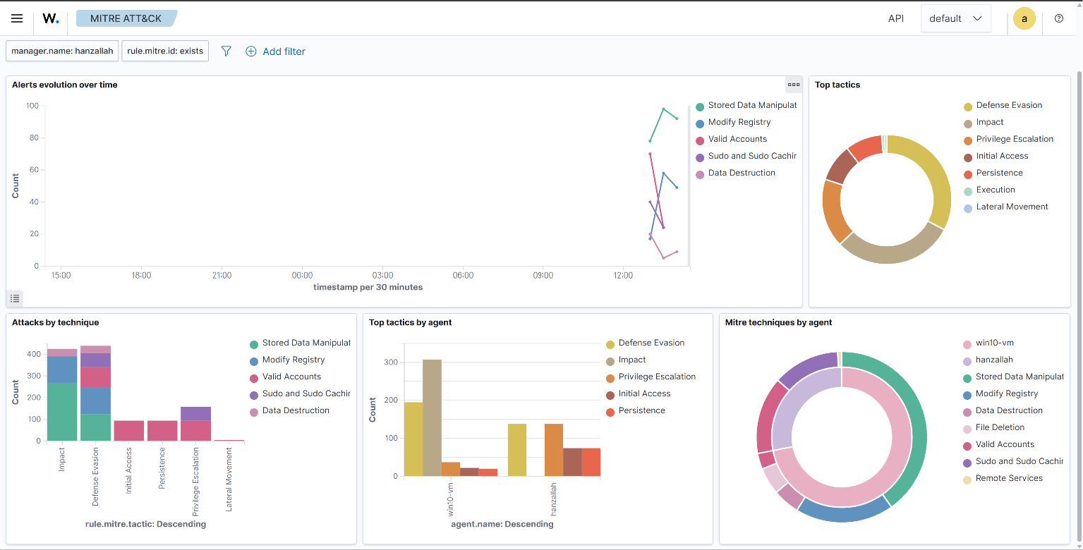
Wazuh MITRE ATT&CK matrix view — techniques mapped from lab alert history
Note: table to be completed with at least 3 distinct techniques pulled from the ATT&CK matrix view, cross-referenced against Days 1–21 alert history (SSH brute force, FIM events, Suricata network alerts).
$ threat_feed_integration_(cdb_lists)
External threat feeds from Abuse.ch (Feodo Tracker) were pulled and loaded into a Wazuh CDB list, allowing rule-based lookups against known-malicious IP addresses.
cd /var/ossec/etc/lists
curl -o malicious-ips.txt https://feodotracker.abuse.ch/downloads/ipblocklist.txt
grep -v '^#' malicious-ips.txt | awk '{print $0":"}' > malicious-ips-cdb
Registered in ossec.conf:
<ruleset>
<list>etc/lists/malicious-ips-cdb</list>
</ruleset>
Detection rule referencing the list:
<rule id="100300" level="12">
<if_group>ids</if_group>
<list field="srcip" lookup="address_match_key">etc/lists/malicious-ips-cdb</list>
<description>Source IP matches known malicious IP (Abuse.ch feed)</description>
</rule>
[ SCREENSHOT PLACEHOLDER ]
CDB list rule firing against a matched IOC
Status: feed pulled and list registered; pending a live rule-fire test against a matched IOC before this section is finalized.
$ ioc_summary
Indicators observed in the lab environment this week, enriched with external threat intelligence.
Indicator | Type | Source | Association | Recommended action
8b3f1918199319d1f2cef7289239b5f77c00b079847b9c2636e56854d1e5eff71 | File hash (SHA256) | VirusTotal (62/74 engines) | EICAR-Standard-AV-Test-File — synthetic test signature, not a live threat | No action required in this lab context; in production, a hash with this detection rate would be quarantined and the host isolated pending investigation.
TBD | IP address | Abuse.ch Feodo Tracker | TBD | TBD

$ deliverables_in_this_report
- VirusTotal integration — configuration, root-cause fix for the deprecated v2 API bug, and validated end-to-end enrichment test (screenshot pending).
- MITRE ATT&CK technique map — module enabled and verified accessible; technique table pending completion (screenshot pending).
- CDB threat feed integration — Abuse.ch feed pulled, CDB list registered, detection rule written; live-fire validation pending (screenshot pending).
- IOC summary — one indicator fully documented (EICAR test hash); pending indicators from CDB/Suricata test activity.

